A Fishbone diagram, also called a Cause-and-Effect diagram, can help teams in identifying possible causes of a problem and in sorting ideas into useful categories. A fishbone diagram is a visual way to look at cause and effect and helps teams focus on causes rather than symptoms.

Logistics

Roles: Facilitator, Notetaker, Timekeeper
Size: 3-7 people
Time: 30-40 min

Materials

In-person: Poster paper (posted prior to engaging in the protocol), markers, notebooks, and post-its.
Virtual: Google Jamboard, virtual slide decks, or another shared brainstorm space, and digital space to diagram the Fishbone.

Instructions for Use

1. Define the problem.
First, draw or place the fishbone diagram on poster paper or electronically for the group to see. As a team, identify the problem to be addressed. Document it on the head of the fish on the right-hand side of the diagram. (5-7 min)

2. Brainstorm the causes of the problem. Ask: “Why does this happen?” Invite participants to independently write down potential causes based on their root cause analysis investigation and their knowledge of the system.. Direct participants to transfer causes to post-its, with one cause per post-it. (5 min)
3. Share out and group like causes. Invite participants to share one cause at a time and hand the cause to the recorder to begin organizing into like categories. Continue until all causes have been shared. During this process, engage participants by asking for feedback on groupings. (15 min)
4. Label categories. Invite participants to propose category titles. Elicit feedback to identify if participants believe all causes are in the most accurate categories. (5 min)
Note: There may be causes that are outliers. Place those on a “parking lot” to the side.

5. Equity Pause
Equity Pause:
1. Who is at the table? Who is missing?
2. How might our current processes/practices/beliefs be contributing to inequity?
3. Embrace “We, not They.” Focus on what YOU can change.

6. Reflect. Ask: “Do these causes reflect our initial hunches around why this problem is happening?” Make any additional changes. Finalize categories. This may include grouping categories or creating subcategories. (5 min)
7. Close and identify next steps. Invite participants to reflect on their original brainstorm and the completed Fishbone. Consider how the team’s thinking about the problem has evolved. If the ideas need to be transferred to the fishbone document included, identify who will complete that. (3 min)

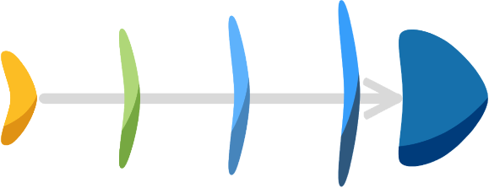
Enter Cause Here
Enter Cause Here
Enter Cause Here
Enter Cause Here
Problem
Enter Cause Here
Enter Cause Here
Enter Cause Here
Enter Cause Here
Category

Category

Category

Enter Cause Here
Enter Cause Here
Enter Cause Here
Enter Cause Here
Category

Category

Category

